Note 1 Curation of benchmark datasets
The Benchmark dataset constructed in this study was sourced from multiple public databases (Fig. S1, Table S1), encompassing three major categories: bulk sequencing data, single-cell sequencing data, and spatial transcriptomics (ST) data. These resources cover diverse species (e.g., human and mouse), various tissue states (e.g., healthy and diseased tissues), and multiple experimental technological platforms (e.g., Visium, Slide-seq, and Stereo-seq), ensuring the comprehensiveness and diversity of the dataset. Spatial transcriptomics data form the core of the study, including samples with different resolutions and spatial coverage, providing the essential data foundation for differential expression analysis across spatial domains. Furthermore, the spatial domains within the dataset specifically include manually annotated anatomical and disease domains defined by biologists, as well as algorithmically identified tissue domains (e.g., using GraphST), further enhancing the broad applicability of the data. By integrating and analyzing these data, we aim to validate the universality and statistical significance of the High-Purity Differential Expression (HiP-DEP) pattern in spatial domains. The following section details the various types of data collected in this study.
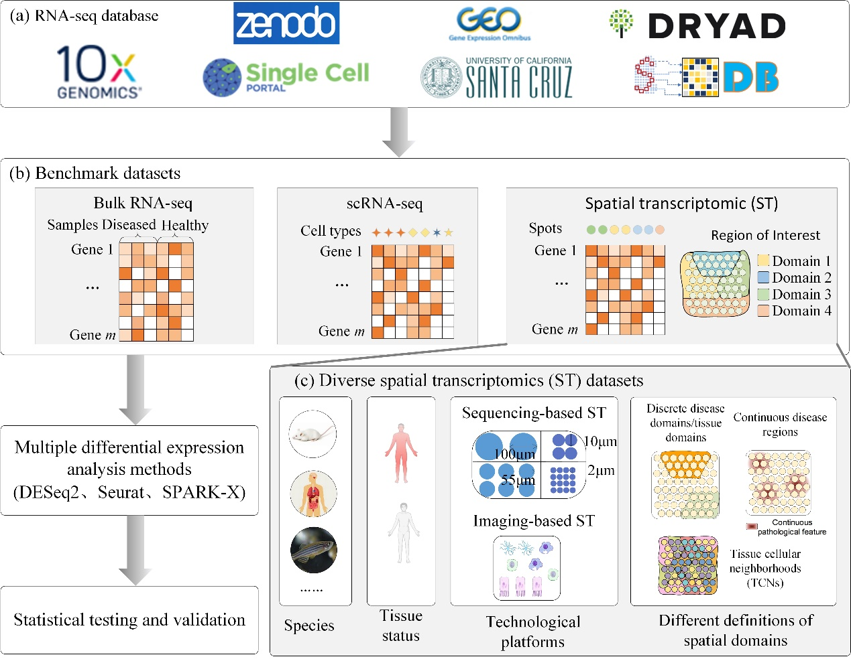
Figure S1. Overview of the benchmark datasets for HiP-DEP. (a) Data resources. Public repositories for RNA-seq data, including 10x Genomics, Gene Expression Omnibus (GEO), Single Cell Portal, Zenodo, and Dryad, which were utilized to curate the data for this study. (b) Construction of benchmark datasets. Schematic representation of the three data types integrated into the HiP-DEP framework for comparative analysis: (i) Bulk RNA-seq, comparing diseased versus healthy samples; (ii) Single-cell RNA-seq (scRNA-seq), comparing specific cell types; (iii) Spatial transcriptomics (ST), comparing gene expression between a defined spatial domain and all other spots within a tissue section. (c) Analysis of diverse ST datasets. The core HiP-DEP workflow applied to a comprehensive ST benchmark. The datasets are characterized by multiple variables: Species, Tissue status (e.g., healthy/diseased), Technology platforms (sequencing-based or imaging-based), and Definitions of spatial domains. Domains include discrete annotations (e.g., disease/tissue domains, tissue cellular neighborhoods) and regions defined by continuous pathological features. Multiple differential expression analysis methods (e.g., DESeq2, Seurat, SPARK-X) are applied, followed by statistical testing and validation to establish the prevalence and specificity of the High-Purity Differential Expression (HiP-DEP) pattern.
Table S1 RNA-seq database
Database | Link address | Description
10x Genomics^{[1]} | https://www.10xgenomics.com/ | Repository for single-cell and spatial transcriptomics data.
Single Cell Portal^{[2]} | https://singlecell.broadinstitute.org/ | Data sharing platform for single-cell genomics.
NCBI GEO^{[3]} | https://www.ncbi.nlm.nih.gov/geo/ | Public repository for functional genomics data sets.
Zenodo | https://zenodo.org/ | General-purpose open-access repository for research data.
Dryad | https://datadryad.org/ | Digital repository for research data, including bulk and single-cell sequencing data.
Xena Browser^{[4]} | https://xenabrowser.net/ | Cancer genomics platform primarily for bulk sequencing data analysis.
SpatialOmics^{[5]} | https://gene.ai.tencent.com/SpatialOmics/ | Dedicated database for spatial transcriptomics and proteomics data.

The advancement of spatial transcriptomics technology has provided crucial means for the spatial mapping of gene expression, with different sequencing platforms generating various types of ST data. These data exhibit high diversity in terms of species origin, tissue type, and data resolution. Common ST technologies include sequencing-based platforms like standard ST, 10x Visium, and Slide-seq V2, as well as imaging-based platforms like MERFISH and seqFISH+. In sequencing-based ST data, as resolution increases, gene detection capability may become limited; some genes might not be detected, and the number of detectable genes decreases significantly. For instance, data generated by Stereo-seq technology can achieve subcellular resolution, but the number of detected genes is only around 1,000. Imaging-based ST data can measure gene expression at single-cell or subcellular spatial scales but require specific probes designed for target genes, resulting in a lower number of detected genes. The detection limitations of high-resolution, low-throughput ST techniques can lead to very few differentially expressed genes being identified, making the subsequent analysis of their differential expression patterns unreliable.
To effectively validate the observed HiP-DEP pattern in spatial domains, this study comprehensively considered both resolution and gene detection throughput, selecting multiple ST datasets generated from different platforms. As summarized in Fig. S2, which details the data sources and descriptions, these datasets cover multiple tissues from various species, including human, mouse, and axolotl, and tissues such as the brain, skin, and lung. Additionally, the data samples include both healthy tissues and diseased states, enabling the analysis of expression patterns in spatial domains from a pathological perspective. The datasets shown in the figure were generated by 10x Visium, Slide-seq V2, seqFISH+, and Stereo-seq technologies, encompassing resolutions ranging from multicellular to subcellular and gene detection counts from 1,000 to 200,000. By considering this spectrum of resolutions and gene detection counts, we validate that the high-purity differential expression phenomenon is universally present across spatial domains.
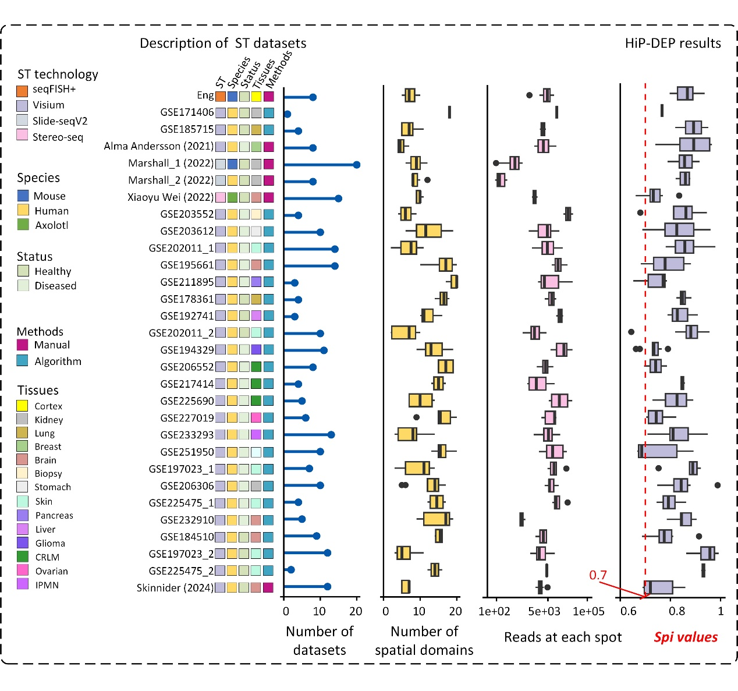
Figure S2. Spatial transcriptomics benchmark datasets for test. Here provides a multi-dimensional characterization of the 190 spatial transcriptomics (ST) datasets from 30 sources comprising the benchmark, summarizing their technical, biological, and analytical attributes alongside the resulting Spatial Purity Index (SPi). Each row represents a single ST dataset, annotated by a series of categorical variables (indicated by colored boxes from left to right): ST Technology- The experimental platform (e.g., seqFISH+, Visium, Slide-seqV2). Species- The organism of origin (Mouse, Human, Axolotl). Status: Healthy or Diseased. Domain Definition Method- The approach used to define spatial domains (Manual annotation or Algorithm-based detection). Tissue- The anatomical source of the sample. Three panels provide quantitative summaries: The total Number of Datasets (bar plot) and the total Number of Spatial Domains (box plot) analyzed across the benchmark; The distribution of sequencing depth, represented as the Number of reads at each spot; The vaules of the Spatial Purity Index (SPi) calculated for all spatial domains across the benchmark. The red dashed line marks the SPi = 0.7 threshold, above which a domain is considered to exhibit a high-purity HiP-DEP.
To contrast the HiP-DEP pattern in spatial domains with the low-purity differential expression conventionally observed in bulk sequencing data, this study collected bulk sequencing data for 18 cancer types from the Xena Browser database, with details provided in Table S2. Concurrently, to investigate whether differential expression between different cell types in single-cell RNA-seq (scRNA-seq) data shares the same characteristics observed in spatial domains, we collected scRNA-seq data representing multiple cell types from 23 human tissues. The tissue information and the corresponding number of cell types are illustrated in Fig. S3. Based on these three data types, this study constructed a Benchmark dataset that includes multi-technology spatial transcriptomic data, scRNA-seq data from multiple tissues, and bulk sequencing data, with the differential expression results from the bulk data serving as the baseline. This design aims to compare the characteristics and patterns of different data types through a unified analytical framework, specifically exploring the unique manifestation of the HiP-DEP pattern in spatial domains relative to conventional data types. Given the widespread application and extensive accumulation of bulk sequencing data, whose expression patterns have been thoroughly validated in past research, its selection as a baseline is reasonable and provides a valuable reference. Similarly, the expression characteristics of different cell types in scRNA-seq data are of significant interest. Compared to spatial transcriptomic data, scRNA-seq data lacks spatial information, and its expression features are closely related to cell type or state. Selecting this data type as a control helps elucidate the factors associated with the HiP-DEP pattern.
Table S2 18 Bulk RNA-seq datasets for test
Cancer Type (Abbreviation) | Purity index
Bladder Cancer (BLCA) | 0.5981308
Breast Cancer (BRCA) | 0.5106383
Bile Duct Cancer (CHOL) | 0.5784314
Colon Cancer (COAD) | 0.5042017
Esophageal Cancer (ESCA) | 0.5057471
Head and Neck Cancer (HNSC) | 0.5287009
Kidney Clear Cell Carcinoma (KIRC) | 0.5568238
Liver Cancer (LIHC) | 0.6020619
Lung Adenocarcinoma (LUAD) | 0.6276295
Lung Squamous Cell Carcinoma (LUSC) | 0.5664373
Endometrioid Cancer (UCEC) | 0.6510523
Glioblastoma (GBM) | 0.6425716
Kidney Chromophobe (KICH) | 0.7744439
Kidney Papillary Cell Carcinoma (KIRP) | 0.6786289
Prostate Cancer (PRAD) | 0.5293729
Rectal Cancer (READ) | 0.529316
Stomach Cancer (STAD) | 0.5760456
Thyroid Cancer (THCA) | 0.5521886

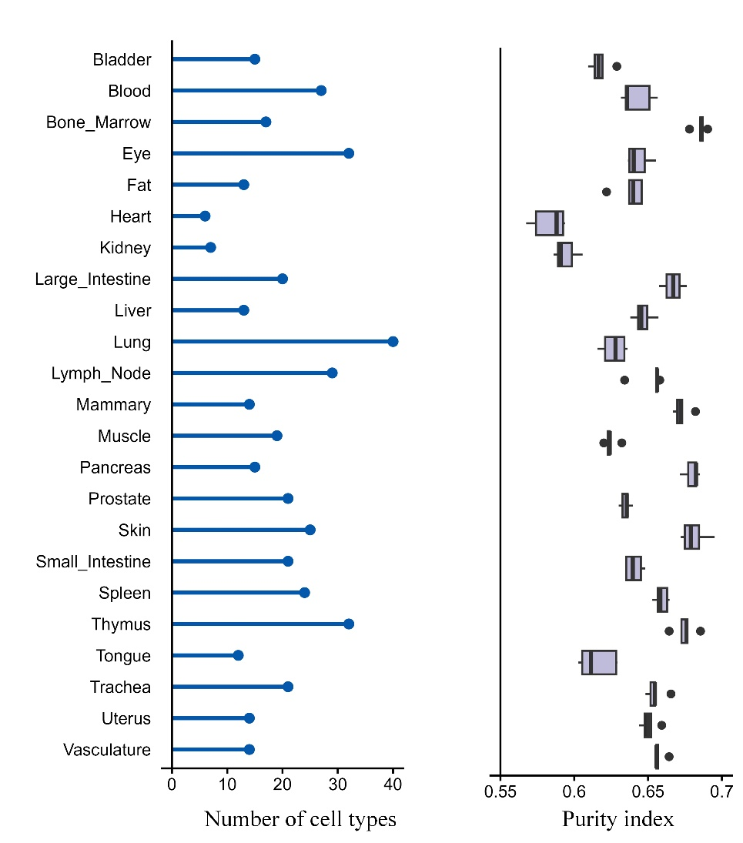
Figure S3. scRNA-seq datasets for test. Left panel (Bar plot): Number of distinct cell types identified in 23 human tissues. Right panel (Box plot): Values of the Spatial Purity Index for the corresponding tissues. Each box represents the SPi values calculated across multiple cell types.

Note 2 Detailed process of method
The TPM (Transcripts Per Million) normalization method^{[6]} is utilized to reduce the influence of sequencing depth and technical biases on samples. The following presents the preprocessing process of Algorithm 1 as well as the process of TPM normalization.
Algorithm 1: ST Data Preprocessing
Input: ST gene expression matrix K, gene set G, spatial spot set S, minimum proportion of gene expression in spots Sratio, minimum proportion of spot expression in genes Gratio;
Output: Processed gene expression matrix , filtered gene set , filtered spatial spot set ;
- Initialize , , ;
- for each gene i in G do
- Calculate the proportion of non-zero entries in row i of K;
- If then
- Add i to ;
- for each spot j in S do
- Calculate the proportion of non-zero entries in column j of K;
- If then
- Add j to ;
- Filter K to retain rows in and columns in , assign to ;
- Return , , .
In this paper, the expression count matrix of spatial transcriptomics (ST) data is denoted as , with rows corresponding to genes and columns to spatial spots, representing expression values across spatial spots. Let represent the gene set and the spatial spots set . The coordinate matrix of these spatial spots is denoted as , where each row contains the d-dimensional coordinates of a spatial spot. Spatial coordinates may exist in two-dimensional (d=2) or three-dimensional (d=3) space. For instance, ST data from Stereo-seq technology includes three-dimensional spatial location information.
Next, TPM is applied to the filtered expression matrix to mitigate sequencing depth effects and balance technical biases across samples. TPM is a normalization method for gene expression data. This method first calculates the proportion of each gene's expression level in the total expression level (i.e., the expression level of each gene per million reads), and then multiplies this proportion by 1,000,000 to obtain the TPM value. The calculation formula for TPM is as follows: The TPM value for gene i in spot j is calculated as:
(1)
where is the read count for gene i in spot j, is the gene length (or a normalized effective length), and the denominator represents the sum of length-scaled counts for all m genes in spot j.
In differential expression analysis, the p-value is used to detect whether there are significant differences in gene expression between the experimental group and the control group, which is calculated through statistical tests. The logFC is used to describe the differences in gene expression between the two groups. When logFC is positive, it indicates that the gene expression is up-regulated in the treatment group; otherwise, it means that the gene expression is down-regulated in the treatment group. The p-value tests the significance of the expression difference, and the logFC assesses the actual magnitude of the difference. These two are crucial for the biological significance of differential expression.
Algorithm 2: Differential Expression Analysis for ST data
Input: Gene expression matrix K, spatial domain annotation matrix D, spatial spot set S, spatial domain set R;
Output: Differential expression results (p-value matrix) and (logFC matrix) for all domains;
- for each spatial domain r in R do
- Extract spot indices belonging to domain r from D;
- Construct domain-specific matrix for K using all rows and columns in ;
- Construct matrix for K using all rows and columns not in ;
- Compute differential expression between and using Eq. 5, yielding and .
- Aggregate results across all domains to form global and
- Return (,).

The Kruskal-Wallis test[7] evaluates if multiple independent samples originate from the same distribution. The null hypothesis posits that all group data share a common distribution, while the alternative suggests at least one group's distribution differs. This test assesses significant differences between groups by comparing their rank sums. Given k groups with respective sample sizes , the test statistic H is computed using the following formula:
(2)
where represents the rank sum of the i-th group, and n is the total number of data sets. The statistic H indicates the extent of differences in data distribution among groups. If H surpasses the critical value of the chi-square distribution, the null hypothesis is rejected, signifying significant distribution differences between at least two groups. An H value closer to zero suggests less pronounced differences among the groups. H follows a chi-square distribution with k-1 degrees of freedom. The formula for calculating the p value from the statistic H is as follows:
(3)
Rejecting the null hypothesis () implies at least one group's data distribution differs. However, the Kruskal-Wallis test does not specify which group deviates. Identifying specific group differences requires post-hoc analysis, such as the Dunn or Mann-Whitney U tests. In this study, the Mann-Whitney U test is employed to compare differences between each pair of groups with significantly different Purity distributions, allowing determination of statistical significance between pairs. Given two data groups and with sample sizes and , and rank values and , the U statistic is calculated as follows:
(4)
The Mann-Whitney U test^{[8]} is determined by selecting the smaller value between and :
(5)
For small samples (e.g., ), U is compared to critical values from a Mann-Whitney U table to assess significance. For larger samples, a normal distribution approximation is used to compute the p value. First, calculate the expected value and standard deviation of U:
(6)
(7)
Then, convert U to a Z score using the standard normal distribution:
(8)
The p value is derived from Z. This method allows us to evaluate statistical significance between groups for Purity in bulk RNA-seq, scRNA-seq, and ST data, identifying significant differences between groups.

References
[1] Zheng, G. X. Y. et al. (2017). Massively parallel digital transcriptional profiling of single cells. Nature Communications 8: 1-12, doi:10.1038/ncomms14049
[2] Tarhan L, Bistline J, Chang J, Galloway B, Hanna E, Weitz E. Single Cell Portal: an interactive home for single-cell genomics data. bioRxiv [Preprint]. 2023 Jul 17:2023.07.13.548886. doi: 10.1101/2023.07.13.548886. PMID: 37502904; PMCID: PMC10370058.
[3] Barrett T, Wilhite SE, Ledoux P, Evangelista C, Kim IF, Tomashevsky M, Marshall KA, Phillippy KH, Sherman PM, Holko M, Yefanov A, Lee H, Zhang N, Robertson CL, Serova N, Davis S, Soboleva A. NCBI GEO: archive for functional genomics data sets--update. Nucleic Acids Res. 2013 Jan;41(Database issue):D991-5.
[4] Goldman, M.J., Craft, B., Hastie, M. et al. Visualizing and interpreting cancer genomics data via the Xena platform. Nat Biotechnol (2020). https://doi.org/10.1038/s41587-020-0546-8
[5] Yuan, Z., Pan, W., Zhao, X. et al. SODB facilitates comprehensive exploration of spatial omics data. Nat Methods (2023). https://doi.org/10.1038/s41592-023-01773-7
[6] Zhao Y, Li M C, Konaté M M, et al. TPM, FPKM, or normalized counts? A comparative study of quantification measures for the analysis of RNA-seq data from the NCI patient-derived models repository[J]. Journal of translational medicine, 2021, 19(1): 269.
[7] Casella G, Berger R. Statistical inference[M]. CRC press, 2024.
[8] MacFarland T W, Yates J M. Introduction to nonparametric statistics for the biological sciences using R[M]. Cham: Springer, 2016.

